Questions:
Use sales-data sheet from assignment-data.xlsx and do the following tasks:
The Managing Director found that there is no clarity in sales-data. He likes to see clear visualization of data in various dimensions. He instructed his junior data scientist “Mr.Bean” to reshape the data.

No. 1:
Mr.Bean decided to display the product details produced by every company, along with supervisor detail. [ Hint: Use Pivot Table]. The expected output is as follows:
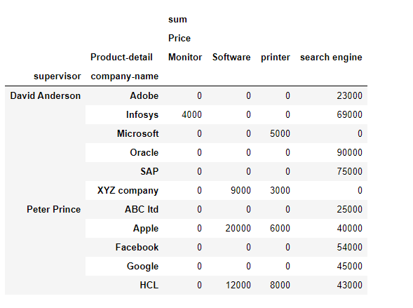
and create a customize plot using matplotlib.

No. 2:

Mr.Bean decided to show the top 5companies that have the most 'total-quantity' ordered. Expected output is as follows
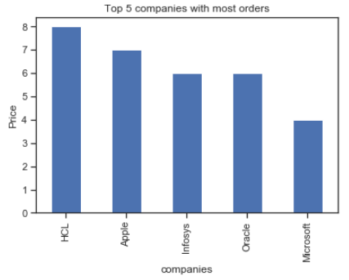

No. 3:

Further, “Mr.Bean” has created a scatterplot showing total-quantity vs Price for 3 companies Apple, HCL and Infosys. Expected output is as follows:
